Appendix
A ‘bad’ Style patterns 57
I Over-complicating Boolean expressions 57
II Usage of ‘magic’ Strings, numbers or characters 57
III Overlong methods 58
IV Long parameter lists 58
V Creating infinite loops 58
VI Looping unnecessarily 59
VII Omitting the default case in a switch 60
VIII Forgetting to break cases in a switch 61
IX Returning temporary variables 62
X Forgetting to initialise arrays 63
XI Forgetting to initialise members of an Object array 63
XII Referencing invalid Array indexes 63
XIII Forgetting that Strings are immutable 64
XIV Shadowing constants 64
B Implemented Style Checks 65
I Over-complicating Boolean expressions 65
II Usage of ‘magic’ Strings, numbers or characters 65
III Overlong methods 65
IV Long parameter lists 66
VII Omitting the default case in a switch 66
VIII Forgetting to break cases in a switch 66
XIV Shadowing constants 66
C Developer’s Guide 67
I Working on KenyaEclipse 67
II Caveats 68
III The Style Guidance Module 68
IV Writing StyleChecks 68
D User Manual 75
I Prerequisites and Installation 75
II The Kenya Perspective 75
III Getting started 76
IV The Kenya/Java editor 78
V Running and Debugging your code 80
VI Bad Style – the Style Guidance Module 86
VII Advanced Editor features 89
VIII Known Issues - Troubleshooting 91
E Time Plans 92
F Learning To Program in Eclipse 95

- ‘bad’ Style patterns
This is a listing of coding patterns (in no particular order) that can be considered ‘bad’ style in the sense that they may: (a-b more or less in order of importance)
- cause the program to behave different from the expectation
- hinder readability or comprehension of the code
- violate principles of object oriented programming
- adversely affect runtime performance in an obvious manner
- Over-complicating Boolean expressions
Category: | b
Description: | For example, a student might write:  if( cond == true )  or  if( cond ) {  return true;  } else {  return false;  }
Solution: | The above should be written as:  if( cond )  and  return cond;
Rationale: | To improve conciseness and readability of the code
Automation: | Possible
- Usage of ‘magic’ Strings, numbers or characters
Category: | c
Description: | ‘Magic’ Strings are String literals that are hard coded in multiple places in the code. (similar for number and characters)
Solution: | Declare the String/number/character as a constant
Rationale: | To encourage code reuse and remove duplication
Automation: | Possible
- Overlong methods
Category: | b, c (metric based)
Description: | Very long methods are hard to read. It may also indicate that the method is doing ‘too much’, i.e. things that lie outside its responsibility.
Solution: | Split method into smaller functional components.
Rationale: | To encourage code reuse and method specialisation (cohesion)  To improve conciseness and readability of the code
Automation: | not possible without user interaction
- Long parameter lists
Category: | b, c (metric based)
Description: | A method that takes many parameters may be inadequately placed and/or do ‘too much’.
Solution: | Split method into smaller functional components or consider the use of objects that group co-occurring variables (e.g. use a class Point instead of using int x and int y together).
Rationale: | To encourage code reuse and method specialisation (cohesion)  To encourage use of Objects (-> Abstract Data Types)  To improve conciseness and readability of the code
Automation: | not possible without user interaction
- Creating infinite loops
Category: | a, d
Description: | Example of an infinite while loop:  int i = 5;  while(i==5) {  //there is no break statement  //there is no statement that alters i  }  Examples of an infinite for loop:  for(int i=0; i>=0; i++) {  //there is no break statement  //there is no break statement  }
Solution: | Each of the above needs a revision of the loop condition or at least one case where a break, i.e. an escape from the loop is possible.
Rationale: | To prevent erroneous program behaviour
Automation: | Not easily achieved because of semantical issues
- Looping unnecessarily
Category: | b, d
Description: | A lot of lab assignments involve looping over an array once this data type has been introduced. Often this involves searching for an item in the array and returning its value, or whether it exists or not.  In this case students may forget that it is more efficient to return from the loop once the item has been found or rather, once the purpose of the loop has fulfilled its purpose.  For example:  boolean doesExist(int num, int[] index) {  boolean result = false;  for(int i=0; i<index.length; i++) {  result |= (index[i] == num);  }  return result;  }
Solution: | It is more efficient to return immediately, once it has been established that the item does exist:  boolean doesExist(int num, int[] index) {  for(int i=0; i<index.length; i++) {  if(index[i] == num ) {  return true;  }  }  return false;  }
Rationale: | To encourage good programming practice
Automation: | With restrictions as the semantics are not clear
- Omitting the default case in a switch
Category: | a
Description: | The mistake is to omit the default case from a switch statement and later assume that one of the cases was a match.  For example (with appropriate class and constant declarations):  Box bigOrSmall(int type) {  Box b;  switch(type) {  case BIG: {  b.size = BIGSIZE;  break;  }  case SMALL: {  b.size = SMALLSIZE;  break;  }  }  println(“b’s width is ” + o.size.width);  […]  return b;  }  The invocation of o.size.width causes a NullPointerException to be thrown in the case where type was neither BIG nor SMALL.
Solution: | The example above might return null immediately if ctype did not match BIG or SMALL:  Box bigOrSmall(int type) {  Box b;  switch(type) {  case BIG: {  b.size = BIGSIZE;  break;  }  case SMALL: {  b.size = SMALLSIZE;  break;  }  default: {  return null;  }  }  println(“b’s width is ” + o.size.width);  […]  return b;  }
Rationale: | To encourage good programming practice  To prevent erroneous behaviour
Automation: | Possible, but the user has to fill the default clause.
- Forgetting to break cases in a switch
Category: | a
Description: | Forgetting the break clause in a switch case is often unintentional and happens because the programmer is in a hurry or in the beginning because of unfamiliarity with the language.  String bigOrSmall(int ctype) {  String s;  switch(ctype) {  case BIG: {  s = “ big”;  }  case SMALL: {  s = “ small ”;  }  default: {  s = “neither big nor small”;  }  }  println(“s is ” + s);  […]  return s;  }  The implementation above always returns “neither big nor small”. This kind of error may be hard to trace for a novice.
Solution: | The above becomes:  String bigOrSmall(int ctype) {  String s;  switch(ctype) {  case BIG: {  s = “big”;  break;  }  case SMALL: {  s = “small”;  break;  }  default: {  s = “neither big nor small”;  }  }  println(“s is ” + s);  […]  return s;  }  Breaking in the default clause is not required, but might also be encouraged in order to maintain a level of consistency.  In cases where the fall through of a case is intentional, this should be explicitly marked by an appropriate comment:  String bigOrSmall(int ctype) {  String s;  switch(ctype) {  case BIG: {  //fall through  }  case SMALL: {  o = “either big or small”;  break;  }  default: {  s = “neither big nor small”;  }  }  println(“s is ” + s);  […]  return o;  }
Rationale: | To prevent erroneous behaviour  To encourage comment usage to explain ambiguous code
Automation: | User interaction is required, but can in general be achieved
- Returning temporary variables
Category: | b
Description: | This applies only to cases where a temporary variable is created, assigned a value in a block statement (such as switch) and is finally returned without using it for any other purpose than this return:  boolean cond;  […]  int temp  if(cond) {  temp = 50;  } else {  temp = 1000;  }  return temp;
Solution: | If the result of the method is known, return immediately:  boolean cond;  […]  if(cond) {  return 50;  } else {  return 1000;  }
Rationale: | To improve code readability
Automation: | Possible
- Forgetting to initialise arrays
Category: | a
Description: | Forgetting to initialise arrays and then referencing their members results in an exception to be thrown at runtime. The error can be hard to trace by a novice.
Solution: | Check whether arrays are initialised before their first use.
Rationale: | To prevent erroneous program behaviour
Automation: | Possible
- Forgetting to initialise members of an Object array
Category: | a
Description: | It frequently happens that an array is initialised, but the members are not, resulting in a NullPointerException to be thrown:  Point[] points = new Point[3];  […]  points[0].x = 5;
Solution: | Check whether the array contents are initialised.
Rationale: | To prevent erroneous program behaviour
Automation: | Potentially complex
- Referencing invalid Array indexes
Category: | a
Description: | Valid array indexes are any integer from 0 and array.length-1 inclusive. Students may make the mistake of forgetting that Java array indexing starts at 0 and construct a loop that iterates over the end of the array:  int[] nums = new int[5];  […]  for(int i=1; i<=nums.length; i++) {  nums[i]+=2;  }  This code throws an ArrayIndexOutOfBoundsException on the last loop iteration. Furthermore, the index 0 is not included in the operation.
Solution: | The indexes should be adjusted to range from 0 to the length of the array (excluding):  int[] nums = new int[5];  […]  for(int i=0; i<nums.length; i++) {  nums[i]+=2;  }
Rationale: | To prevent erroneous behaviour
Automation: | Possible
- Forgetting that Strings are immutable
Category: | a
Description: | const String checked = “checked: ”;  void main(String[] args) {  String f = args[0];  prependChecked(f);  […]  }  void prependChecked(String s) {  s = checked + s;  }  Here the user expects the argument String f to be changed to its own value prefixed with “checked: ”. However, since Strings are immutable, a method call to prependChecked() actually has absolutely no effect.
Solution: | A solution would be to change the return type of prependChecked() to String and to return the modified String. The return value should be assigned to the argument:  const String checked = “checked: ”;  void main(String[] args) {  String f = args[0];  f = prependChecked(f);  […]  }  String prependChecked(String s) {  s = checked + s;  return s;  }
Rationale: | To prevent erroneous program behaviour
Automation: | Possible
- Shadowing constants
Category: | a, b
Description: | This occurs if the user declares a local variable with the same name as a constant. The local declaration has precedence and thus prevents usage of the constant, while the user might think the opposite.
Solution: | The easiest way to avoid this situation is to rename the local variable and all its occurrences to remove the clash in naming.
Rationale: | To prevent unanticipated behaviour  To avoid the ‘need’ for unreadable code
Automation: | Possible

- Implemented Style Checks
This is a listing of all implemented StyleCheckers by proposals as defined in Appendix A. All classes and IDs are prefixed with kenya.eclipse.style.checks. The default value for the ‘defaultEnabled’ flag is true and thus omitted in most cases.
I Over-complicating Boolean expressions
name | Check for overcomplicated booleans
ID | bool.BooleanExpressionChecker
class | bool.BooleanExpressionChecker
name | Check for notorious ‘If return true else return false’
ID | bool.IfReturnElseReturnChecker
class | bool.IfReturnElseReturnChecker
name | Check for empty ‘if’ blocks
ID | bool.EmptyIfElseChecker
class | bool.EmptyIfElseChecker
II Usage of ‘magic’ Strings, numbers or characters
name | Magic string Checker
ID | magic.MagicStringChecker
class | magic.MagicStringChecker
name | Magic char Checker
ID | magic.MagicCharChecker
class | magic.MagicCharChecker
name | Magic int/double Checker
ID | magic.MagicNumberChecker
class | magic.MagicNumberChecker
III Overlong methods
name | Check for method length > 10
ID | metrics.MethodLengthChecker10
class | metrics.MethodLengthChecker
defaultEnabled | false
custom attributes | length = 10
name | Check for method length > 20
ID | metrics.MethodLengthChecker20
class | metrics.MethodLengthChecker
defaultEnabled | true
custom attributes | length = 20
name | Check for method length > 50
ID | metrics.MethodLengthChecker50
class | metrics.MethodLengthChecker
defaultEnabled | false
custom attributes | length = 50
IV Long parameter lists
name | Check for long parameter lists ( > 8 )
ID | metrics.ParameterLengthChecker
class | metrics.ParameterLengthChecker
defaultEnabled | true
custom attributes | length = 8
VII Omitting the default case in a switch
name | Check for omission of default case in switch blocks
ID | swit.DefaultOmissionChecker
class | swit.DefaultOmissionChecker
VIII Forgetting to break cases in a switch
name | Check for break statement omission in switch cases
ID | swit.BreakOmissionChecker
class | swit.BreakOmissionChecker
XIV Shadowing constants
name | Check for shadowed constants
ID | scope.ShadowedConstantsChecker
class | scope.ShadowedConstantsChecker

- Developer’s Guide
This guide provides details of how to extend the KenyaEclipse system and in particular how to create new StyleChecks.
- Working on KenyaEclipse
Requirements
- Eclipse IDE version 3.0 or later with platform SDK installed (see caveats)
- KenyaEclipse project source code available from http://doc.ic.ac.uk/kenya
- KenyaEclipse project report, chapter 5.3 – Style Guidance Module (SGM), for a more detailed and functional description of implementation than this guide offers
Package functionality listing
These are all packages of KenyaEclipse (excluding core Kenya packages) and the functionality they contain:

kenya.eclipse. | root package, contains main plugin class and constants
ast. | AST handling, dynamic binding resolution, etc.
buildext. | linkage between compiler and postBuildAnalyser extension
debug. | launching: run and debug classes
bridge. | bridges between StackMachine and the debug model
launcher. | Kenya launcher (declared in plugin.xml)
model. | the debug model, i.e. threads, stackframes, breakpoints, …
sourcelookup. | how the Kenya source code is looked up
ui. | UI related, e.g. InsertEOFAction
multieditor. | everything pertaining to the editor
java. | Java part of the editor
kenya. | Kenya part of the editor (including actions)
completion. | code completion processor and related (ctrl+space)
correction. | code correction processor (e.g. for style) (ctrl+1)
occurrences. | some occurrence finder stuff, main occ. code is in KenyaEditor
refactoring. | these classes are similar to JFace’s TextEdit, etc. classes
util. | utilities, e.g. LocationUtils, AutoIndentStrategy
text. | some code scanners/readers and formatter (unused)
util. | utilities, e.g. JavaInput and provider, KenyaHelperThread
natures. | contains all ‘natures’ (e.g. KenyaNature)
preferences. | contains preference related classes
style. | Style Guidance Module – base classes: registry, manager, etc.
checkerimpl. | base classes for kenyaStyleCheckers extension point
checks. | implementation of style checkers
properties. | e.g. StylePropertyPage for configuration
ui | e.g. content providers for use in StylePropertyPage
ui. | general UI classes

- Caveats
Eclipse version discrepancies
This concerns 3.0 -> 3.1 compatibility issues.
The KenyaEclipse version for Eclipse 3.0 uses inofficial API from debug.ui. The class org.eclipse.debug.internal.ui.stringsubstitution.StringVariableSelectionDialog is directly referenced by kenya.eclipse.debug.ui.launchconfig.ArgumentsTab. The class has been promoted to official API in the 3.1 release and as thus its package has changed. If developing for Eclipse 3.1 and above you must make sure that the import reads org.eclipse.debug.ui.StringVariableSelectionDialog.

The Eclipse milestone build 3.1M5 has introduced an ‘insert EOF’ feature for the Console View. It is activated by a platform specific keyboard command (ctrl-d or ctrl-z). For Eclipse 3.1, the insertEOF action could thus be removed and the manual updated accordingly.
- The Style Guidance Module
The module is exclusively defined in kenya.eclipse.style. The extension point kenya.eclipse.postBuildAnalyserFactories is used to connect the module to the editor. The multieditor class kenya.eclipse.multieditor.EditingWindow manages this extension point.

For a detailed description of the implementation you should either consult the source code for the classes above or obtain a copy of the project report, which contains more details about the extension point and its management.

StyleCheckers are governed by the kenya.eclipse.styleCheckers extension point, which is managed by kenya.eclipse.style.StyleManager.
- Writing StyleChecks
StyleChecks can be supplied in a separate plug-in and need not be packaged in the same archives as KenyaEclipse. The only requirement for this is the availability of the KenyaEclipse plug-in during development and at runtime.

A StyleChecker is the implementation of an extension point and thus has two components: firstly the class implementing the actual check, and secondly the declaration in the plugin.xml descriptor file.
Declaring and implementing a StyleChecker
The extension point itself is declared as follows:
<extension-point
id="styleCheckers"
name="Kenya Style Checkers"
schema="schema/styleCheckers.exsd"
/>
Extension point description:
Identifier: kenya.eclipse.KenyaStyle.styleCheckers
Configuration Markup:
<!ELEMENT extension (KenyaStyleChecker)>
<!ATTLIST extension
id CDATA #IMPLIED
name CDATA #IMPLIED
point CDATA #REQUIRED>

<!ELEMENT KenyaStyleChecker (customAttribute)>
<!ATTLIST KenyaStyleChecker
class CDATA #REQUIRED
id CDATA #REQUIRED
name CDATA #REQUIRED
defaultEnabled (true | false) >
- class - Fully qualified name of a class that implements IStyleChecker
- id - unique identifier for the checker
- name - A name which will be used in the preference panel, a short description would be good.
- defaultEnabled - whether or not this check should be enabled by default, the default value is 'true'.

<!ELEMENT customAttribute EMPTY>
<!ATTLIST customAttribute
name CDATA #REQUIRED
value CDATA #REQUIRED>
- name - name of the attribute (map key)
- value - value of the attribute (map value)

Each extension encompasses one or more ‘KenyaStyleChecker’s, which require attributes as above.

The name is actually displayed on the configuration page and should be chosen to be a short description of the checker.
The defaultEnabled flag specifies whether the check is enabled by default. This may be useful if providing a StyleChecker with custom attributes (see below), where the class can be reused multiple times, but only one of them should be enabled initially.
It is usually sufficient to use the same value for id as for the class, but note that if the same class is used, then the id has to be unique for each declaration.
A good example if this is the provided MethodLengthChecker.

Finally, KenyaStyleCheckers may contain multiple ‘customAttribute’s, which are mappings of keys to values. These can be used to create reusable StyleCheckers.

Here, we will take the ‘Long parameter list’ checker as an example and see how it is declared and implemented in the plug-in. Although the extension point definition seen above looks complex, it boils down to only a few lines.

Declaration
The checker is declared in the plugin.xml file as follows:

<KenyaStyleChecker
class="kenya.eclipse.style.checks.metrics.ParameterLengthChecker"
name="Check for long parameter lists ( &gt; 8 )"
id="kenya.eclipse.style.checks.metrics.ParameterLengthChecker8">
<customAttribute name="length" value="8" />
</KenyaStyleChecker>
Note:
id is the unique identifier. Since this StyleChecker can be configured with different values for its ‘length’ attribute, that value has been appended
customAttribute with name ‘length’ and the value ‘8’.

The defaultEnabled attribute is missing from the declaration since its default value is true, although it might be included for added clarity.

And that is it. This is all the markup required to integrate a StyleChecker with the framework. Only the implementation needs to be added.

Implementation
The first thing to note is that, while the extension point only requires the implementation to inherit from IStyleChecker, there is an abstract implementation available, providing various useful methods for use by its subclasses.

We can create our class, extending AbstractStyleChecker, which requires us to implement the two methods:
void configure(java.util.Map)
void performCheck(mediator.ICheckedCode, IFile file).

configure is called first and passes all custom attributes declared using the customAttribute tag to the instance of the checker as a map, mapping ‘name’s to ‘value’s. In our implementation, we retrieve the value for the ‘length’ attribute and store it in a field:

private int fMaxLength = Integer.MAX_VALUE; //default is 'infinity'

public void configure(Map customAttributes) {
String ln = (String)customAttributes.get("length");
if(ln!=null) {
try {
int length = Integer.parseInt(ln);
fMaxLength = length;
//retrieve the length from the configuration
} catch(NumberFormatException e) {
//ignore (if fails, we will be using the default value)
}
}
}

The implementation of performCheck can be staged in 3 phases. First, we will perform a search to find all method declarations, since this is the point where we will find parameter lists. Second, we can single out the methods that take more parameters than fMaxLength (see above) and can then in the third phase take action (resolutions and highlighting).
Phase 1
Obtaining method or function references from the code object is simple:

IFunction[] funs = code.getFunctions();

That’s phase 1 done.
Phase 2
We can store the ‘offenders’ in a collection to be able to treat them later. First we need to find these by examining the methods we just found:
//we will need this later
IDocument doc = getDocument(file);

//lengths will contain the offending method's location
// and the number of arguments they accept
HashMap lengths = new HashMap();

//we first examine each function in turn
for(int i = 0; i < funs.length; i++) {
IFunction function = funs[i];
AFuncDecDeclaration decl = function.getDeclarationNode();
//the following is cheating as it
// requires implicit knowledge of the AST.
// the 'proper' way is to use a
// visitor that counts the number of parameters
AFormalParamList paramlist = (AFormalParamList)
decl.getFormalParamList();
if(paramlist==null) {
continue; //no parameters
}
Node n = paramlist.getTypeName();
List list = paramlist.getCommaTypeName();

int length = (n==null)
?0 //if n is null, length is 0
:1 + ( //otherwise 1 for n, and add..
(list==null)
?0 //..0 for a null list
:list.size() //..or its length
);

if(length>fMaxLength) { //test against max length
//we actually wish to highlight the parameter list
ISourceCodeLocation loc
= AdvancedPositionFinder.getFullLocation(paramlist, doc);
lengths.put(loc, new Integer(length));
}
}

Note that we used a map of locations to number of parameters to store the ‘offenders’.
To calculate the position of the parameters in the file, we used superclass functionality to obtain the corresponding IDocument.
Phase 3
The final step is to use the gathered information to create the annotations in the editor.

//can now go through 'offenders' and create the appropriate markers
//this must be done in an IWorkSpaceRunnable
final Set offences = lengths.entrySet();
IWorkspaceRunnable runnable = new IWorkspaceRunnable() {
public void run(IProgressMonitor monitor) throws CoreException {
for(Iterator it = offences.iterator(); it.hasNext();) {
Map.Entry entry = (Map.Entry)it.next();
//retrieve the data from the map

ISourceCodeLocation loc
= (ISourceCodeLocation)entry.getKey();
Integer length = (Integer)entry.getValue();

String msg
= MessageFormat.format(MESSAGE, new Object[]{length});

//super can do the marker creation
createKenyaStyleMarker(file, loc, msg);

}
}
};

where MESSAGE is a constant declared as:
public static final String MESSAGE =
"This method takes {0} parameters. " +
"\nTry splitting the method into " +
"smaller functional parts or creating" +
"\na class to group closely related parameters.";

The {0} is replaced by the length of the parameter list as obtained from the map by the format instruction. The message is used as a label for the created marker and is the text shown, for instance, in the problem view for that particular style warning.

Finally, this runnable needs to be executed. Again, the abstract superclass provides a method for this and we simply call:
//execute the runnable
runMarkerUpdate(runnable);

We have seen:
- how easy it is to write a StyleChecker
- that for more complicated checkers you will need to use the AST and visitors
- that AbstractStyleChecker provides various helpful methods

We have not seen:
- How to create resolutions
Style Resolutions
Resolutions can be created during the execution of the IWorkspaceRunnable. The idea is to instantiate and populate a map, which is defined in the field fResolutionMap. It can be instantiated at any time and populated as required. This map is returned to the framework by a call to the predefined method Map getMarkerResolutionMap(). The map is expected to be populated once the runnable returns and maps from IMarker to IMarkerResolution[].

An IMarker is returned from createKenyaStyleMarker, while the Resolution can be created as an inner class or extension of StyleWarningResolution. This contains all information necessary to perform the resolution.

Use the field fOperation in StyleWarningResolution, which is an instance of DocumentModificationOperation (kenya.eclipse.multieditor.kenya.refactoring), to define text operations that will perform the resolution. If you do not want a modification at all, simply don't touch fOperation. It is still possible to show the resolution dialog.

Here is an example of a StyleWarningResolution implementation:

class BreakOmissionMarkerResolution1 extends StyleWarningResolution {
public BreakOmissionMarkerResolution(IMarker marker) {
super(null, marker, new DocumentModificationOperation());
fLabel = "Create break statement";
initDescription();
init(marker);
}
private void initDescription() {
fDescription = "<p><b>Explanation:</b></p>" +
"<p>A <b>break statement</b> marks the end of a 'case' in a " +
"switch block. This prevents cases from falling through, which " +
"means that the <b>next</b> case is <b>also</b> executed.</p>" +
"<p><b>Note:</b> If the case is intended to fall through, you " +
"should create a <em>fall-through comment</em> instead.</p>";
}
private void init(IMarker marker) {
IDocument doc = getDocument((IFile)marker.getResource());
if(doc==null) { return; }
//find the place where we are supposed to insert our generation
int offset = marker.getAttribute(FIX_OFFSET, -1);

if(offset<0) { return; } //can't continue if no such place defined

String prefix; //line indent
String postfix; //next line indent

[…] //calculate prefix and postfix

String insertion = prefix + "break;" + postfix;

fOperation.addOperation(
DocumentTextOperation.newTextInsertion(offset, insertion));
}
}

Three different text operations are defined, namely insertion, deletion and replacement. You will also have noticed that the description is written using HTML markup. Although not all tags are supported, this provides a way of formatting the displayed text.

Another point to note is the mapping to IMarkerResolution[]. Using an array allows us to specify more than one solution to the problem. In the actual implementation of the BreakOmissionChecker, another resolution is implemented, allowing the addition of a fall-through comment instead of a break statement. All resolutions from the array are added to the proposal box as shown below. Notice also the formatting resulting from the usage of HTML.
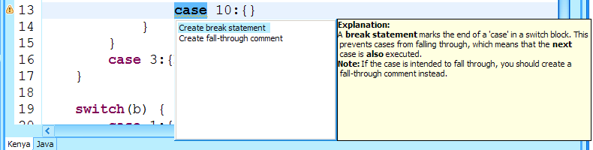

- User Manual
If concepts occurring in this manual are not sufficiently explained, please use the Eclipse Workbench User Guide to complement.
- Prerequisites and Installation
KenyaEclipse is fully compatible with Eclipse version 3.0 and above on all operating systems. To be able to use the plug-in, you need to install a version of Eclipse corresponding to your operating system.

To install KenyaEclipse, obtain the version that is intended for your version of Eclipse, there is one version for Eclipse 3.0 and a separate version for Eclipse 3.1.
KenyaEclipse is distributed in a zip archive (a file with the ending ‘.zip’) and you will require WinZip or an equivalent decompression utility to view the contents.

Using the utility, extract the archives contents to the directory in which you installed Eclipse. The next time you start Eclipse, KenyaEclipse’s functionality will be available for your use.

In order to install this manual into the Eclipse help system, please proceed exactly as above with the archive containing the KenyaEclipseHelp plug-in. It will then be accessible via the Help -> Help Contents link in Eclipse.
- The Kenya Perspective
In order to work with Kenya, you will need to switch to the Kenya Perspective. You can do this by clicking on the menu item Window and selecting Open perspective.
Should a link to the Kenya Perspective not appear in the submenu, then please select Other as shown below and choose Kenya from the list.

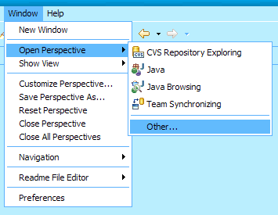

In consequent uses, the Kenya Perspective should now be selected, but can always be activated using the same steps described here.

The Kenya Perspective offers access to all functionality that relates to Kenya, such as the Kenya editor and run and debug support for Kenya programs. The following few chapters explain how to make use of this perspective in order to program with Kenya.
You will notice that you are using the Kenya Perspective by the changed window title.
- Getting started
This chapter describes how to get to the point where you can start writing your first piece of code.
Creating a Kenya Project
In Eclipse everything is done in Projects. There are different kinds of projects for different kind of purposes, such as Java Projects for Java or Kenya Projects for Kenya.
All your work with Kenya should be put into Kenya Projects.

- Inside Eclipse select the menu item File > New > Project.... to open the New Project wizard. Select Kenya Project in the Kenya folder then click Next.
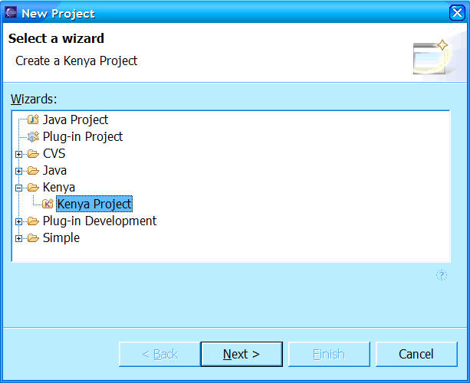
Alternatively, if the Kenya perspective was already open, then you can right click into the Kenya Explorer and select New -> Kenya Project from the menu.
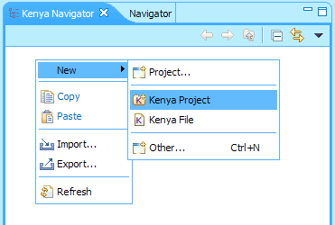
- On the next page, type a name in the Project name field and click Finish. The Kenya perspective automatically opens inside the workbench with the new Kenya project in the Kenya Explorer.
The project is stored on disc in your workspace folder. The Kenya Explorer presents this as a logical location in which you can create, delete and modify files.
Creating a new Kenya file
The Kenya file is the smallest unit inside KenyaEclipse. Each program you write resides in its own file. The New Kenya File wizard makes it easy to create a new program in Eclipse.

  - Inside Eclipse select the menu item File > New > Other to open the New wizard. Select Kenya File in the Kenya folder then click Next.
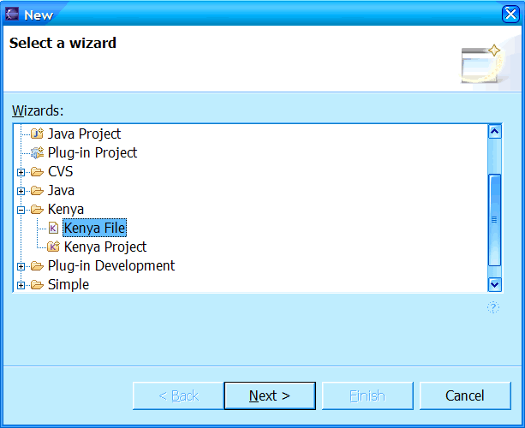

Alternatively, if the Kenya perspective was already open, then you can right click into the Kenya Explorer and select New -> Kenya File from the menu.
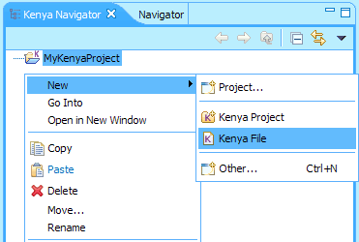
  - The next page asks you to select a container, which is by default the last selected folder or project on the Explorer or navigator.
You are also asked to enter a Type name. This is both the filename and what is in Java known as the Class name. You will notice that certain names are not permitted by convention and you will be given a reason why.
The last thing asked is whether you would like to generate a main method. Since all Kenya programs require a main method to be present, the default is to create one without arguments. The main method will be automatically inserted into the new file, so that you do not need to type it yourself. This is just one of the ways in which an IDE can speed up your development.
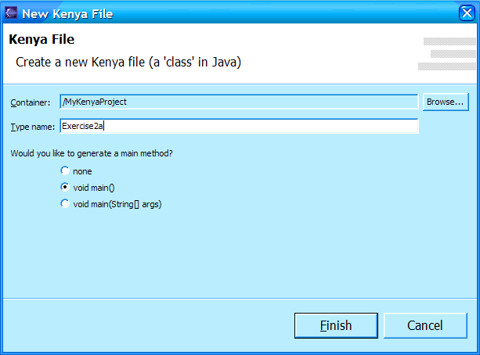
  - The new file will open in the Kenya/Java editor. If you have not yet switched to the Kenya Perspective, you should do it now.
You are now ready to start programming your first Kenya application using KenyaEclipse. How to use the editor and its features is explained in the next chapter.
- The Kenya/Java editor
Layout
The editor consists mainly of two parts. One is where you type Kenya code, the other is where you can view the corresponding Java code (providing your code is error-free).
To switch between the views, all you have to do is use the tabs at the bottom of the editor.
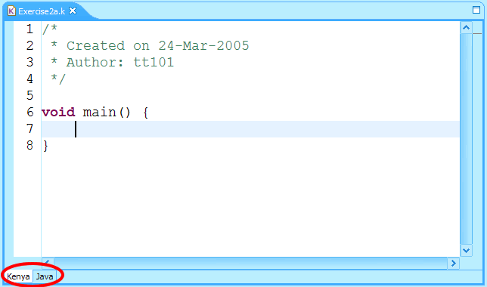

The editor highlights comments, keywords, Strings etc in different colours as you type. It will also highlight errors while you type. The following picture shows a compilation error. In this example the function ‘paint’ is not defined.
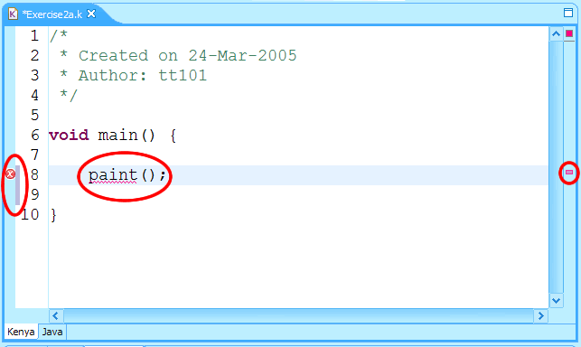
There are four areas of attention in this screenshot:
- red squiggles in the code (simply highlight the error)
- a red cross on the left. That area is called the Annotation Ruler
- a red marker on the right. That area is called the Overview Ruler
- a grey bar next to lines 8 and 9. This is called the Change Ruler

Annotation Ruler
The annotation ruler shows icons for different annotations. These could be errors, warnings, bookmarks, breakpoints, etc., some of which will be covered later. Clicking on the icon will normally highlight the portion of code that is relevant to the annotation.

Overview Ruler
The overview ruler shows small coloured blocks with different colours for different types of annotations, similar to the annotation ruler. The difference is that the overview ruler is scaled to the size of the document. This means that, while the annotation ruler’s visibility is limited to the current part of the code you are looking at, the overview ruler always has the same scale, so you can use it to quickly navigate to an annotation that is not showing on the screen right now.

Change Ruler
The change ruler gives an indication of what has changed in the document since the last time it was saved. This can be quite powerful when trying to track changes that broke the functionality of the program.

Hovering over each of these rulers will give you more information about why they exist. They might contain an error message or the contents of a bookmarked section of code.

Right-clicking allows you to access some settings, add bookmarks, tasks, etc. these actions are also available from the Edit menu item.

The three rulers will be of importance again, when we consider advanced editor features.
Problem view
Problems also have a place in their own view, which resides at the bottom of the screen:
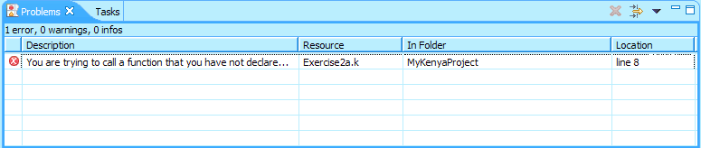
Errors are displayed here even if the file is closed and can be used for quick navigation.
- Running and Debugging your code
Look at this piece of code:
/*
* Created on 24-Mar-2005
* Author: tt101
*/

void main() {
//print the famous words...
println("Hello World!");
}
Its purpose should be quite clear, but of course this isn’t worth anything if it is not possible to execute it. So how do we go about that? The first 3 steps apply to both running and debugging.
Make sure you also read the chapter about the Console View, it is quite important for programming using I/O (Input/Output).

  - Make sure you are working within the Kenya Perspective
Only the Kenya perspective has the functionality to launch Kenya programs.
  - Open the code you want to run or select it in the Kenya Explorer
  - You can now use the launch shortcuts in either the toolbar or the right click menu of the selected file in the Explorer:
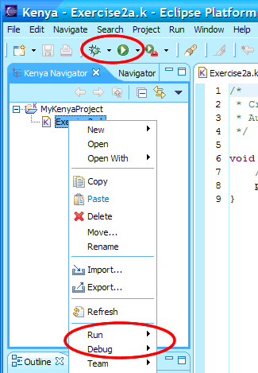
A further way to launch or debug is the Run menu item, but this is not further explained here, you can find out yourself.
Running
To create a new launch configuration, simply click on the arrow next to the icon (in toolbar) and select Run As -> Kenya Application:
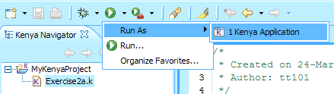

The application will be launched using the external java executable. Note that this can fail if the executable is not on your system PATH. You can try this by opening a command line prompt or shell and typing ‘java’ (without quotes). KenyaEclipse uses the same java executable.

Once you have run an application, you will find a shortcut to run it in the same menu:
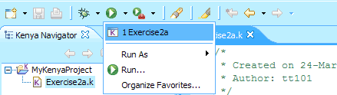
The menu shows the most recent runs with the most recent at the top. Clicking on the icon itself will actually launch the most recent one.
What happens when we run the thing?
You will notice that something happens in the background and that shortly afterwards a new view shows up at the bottom:
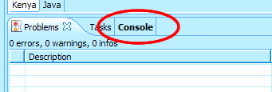
The bold print on the Console tab means that the view contains ‘new contents’. In this case they are of course the results of our run:
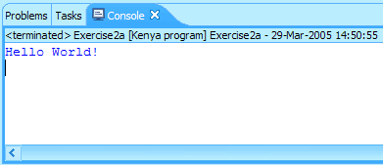
Congratulations, you have run your first application using KenyaEclipse!
Debugging
Debugging allows us to inspect each and every instruction that the program executes, so that we can see where it goes wrong. (Duh, de-bugging)

Make sure you have read the previous chapter on running your code, as it explains some common initial steps.
Debugging is almost exactly the same as running, simply use the arrow next to the bug icon instead:
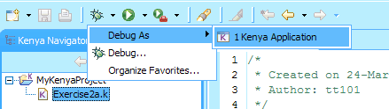
Since we executed our code earlier, you will find that a shortcut to our program already exists, although it would appear after we first debug as well:
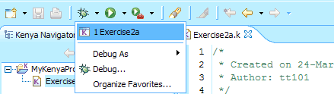
Again, when we run, the Console view will display the output (it looks exactly the same as above).
Breakpoints - what was that about tracing instructions?
To be able to trace, you will first need to create what is called a breakpoint. This is really easy and can be quite powerful. It tells the debugger where to suspend the execution to allow you to inspect the current variables and other things.

The way it works in KenyaEclipse is that you simply double click on the Annotation Ruler in the editor, next to the line in which you create the breakpoint. This will create a breakpoint on the left most instruction in the line and place an icon on the ruler so that you know it is there:
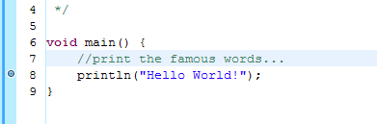
- To remove the breakpoint you can double click on it again and it will disappear.
- Right clicking will allow you to disable/enable it temporarily.
- It is of course possible to set finer grained breakpoints. This is done by first selecting the instruction you wish to break on and then double clicking on the ruler.
- To check which instruction is the one used for the breakpoint, you can single click on the breakpoint annotation.
- To change it, just remove the breakpoint and make a different one using the steps above.
The Debug Perspective
Click on debug again, this time, the following window should pop up:
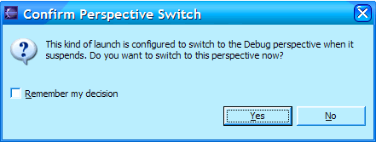
The debugger operates in its own perspective and provides appropriate functionality. To switch to the Debug Perspective, you can click on Yes in the posed dialog.
After confirming the dialog, you will see roughly this picture:
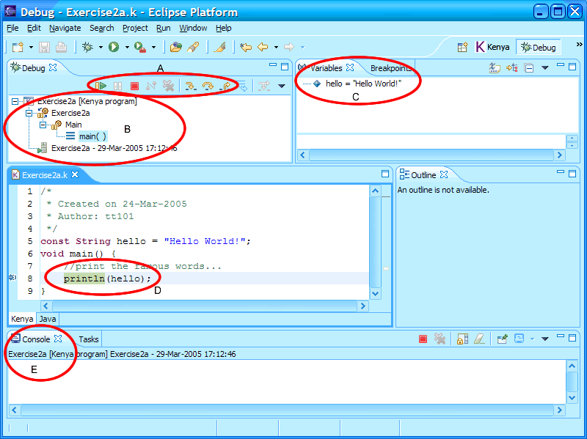
Let me first explain the five components that are highlighted above:
- These tools control the execution of the program. They are in order, resume, suspend, stop, disconnect, clear terminated, step into, step over, step return (and drop to frame). I will soon explain the details for the bold items.
- This view displays the current state of execution down to the method which is currently at the top of the stackframe. If multiple methods are on the stack (one method called the other), then you can click on each one to view its own state of execution in components C and D.
- The variable view allows you to see in detail what variables are declared at the current scope level and watch their values change as you debug your code. The breakpoint view lets you manage your breakpoints for this debug session.
- After clicking on a method in B, this view will jump to the line which is current in that method. In this case you should notice that the execution is supended exactly where we set our breakpoint earlier.
- The console view is back! This view is exactly the same as before and is explained in more detail in a later chapter.
Resume, Stop, Step
These are the main functions used to control execution of the program in debug mode.
Once it has supended (because of a breakpoint you set), you can resume execution by clicking the resume button.
The stop button will cause the program to terminate forcefully and immediately. You can use this to cancel the whole process.
Step into is used to execute the next instruction (the one highlighted in D).
Step over is used to skip the next entire line of instructions (including method calls).
Step return is used to execute everything up to the end of the selected method.
The Console View
Knowing how to use this view is quite important when working with I/O (Input/Output).
If you are working with I/O, you will have come across the read and print methods that are built into Kenya.
Let’s examine the following code:
/*
* Created on 25-Mar-2005
* Author: tt101
*/

void main() {
while(!isEOF()) {
String input = readString();
println("You typed: "+input);
}
}

We follow the same steps as above to start execution and following will happen:

The program waiting for input:
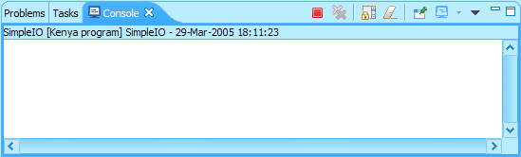

After typing ‘Hello’ and then pressing Enter:
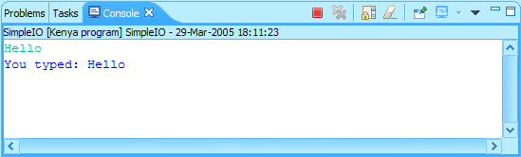

We can of course type things forever, but at some point we need to end the input using EOF (End Of File) so that the program terminates. Click the downward pointing arrow:
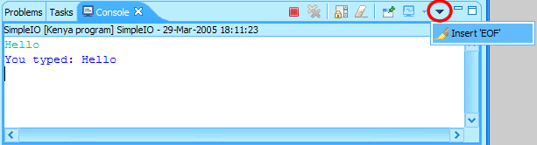

Because of the loop testing for isEOF(), the program is now able to terminate:
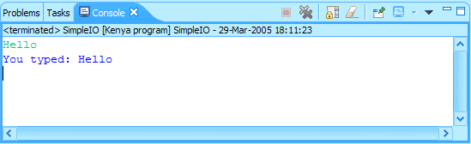
Important points about the console view:
- Input appears in green colour
  - Output appears in blue colour
  - Errors appear in red colour (hopefully that never happens of course)
  - EOF can be achieved by using the console menu
  - The console can terminate the program by using the red stop button
Changing launch settings and specifying arguments
If we go back to the beginning, where we launched our program using the launch shortcuts… Try using the run (or debug) menu item instead:
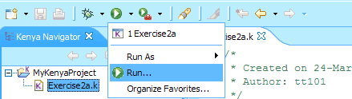
You will be presented with the Launch Configuration Dialog:
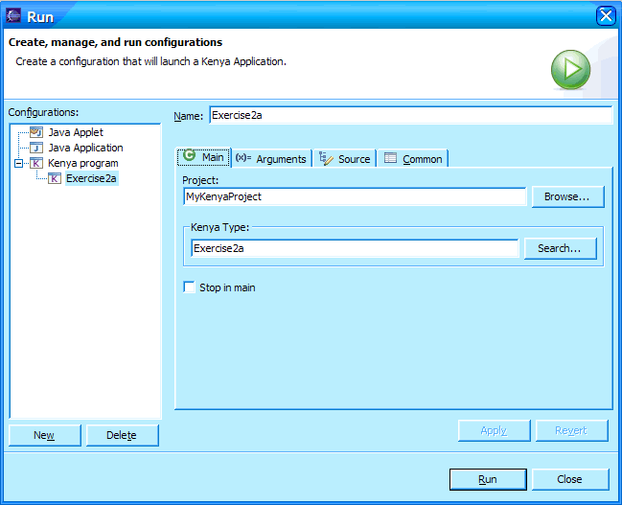
It is best if you explore this dialog yourself. Two options are of particular interest, the first one being the Arguments tab, the second one being the Stop in main checkbox on the Main tab.

You can supply runtime arguments to your program by using the Arguments tab. Arguments are separated by any amount of whitespace, but you can use double quotes to enter arguments that contain spaces.

The Stop in main option is only relevant when you debug your program. If the box is checked, the debugger will automatically suspend upon entering the main method, regardless whether breakpoints are set or not.
- Bad Style – the Style Guidance Module
Style is important in programming and writing ‘bad’ code (code that doesn’t work correctly, is hard to read, is hard to maintain, etc.) either costs you marks, time or your nerves.
KenyaEclipse contains a Style guidance module that picks up common mistakes (everybody does it at least once) and helps you to correct them.

Consider the following code snippet:
void printBoolean(boolean b) {
if( b == true ) {
println("true");
} else {
println("false");
}
}

Even if we don't know what b is, we can say that the expression ‘(b == true)’ is exactly the same as the expression ‘b’.
KenyaEclipse will detect this kind of thing for you and help you do the boolean reduction.
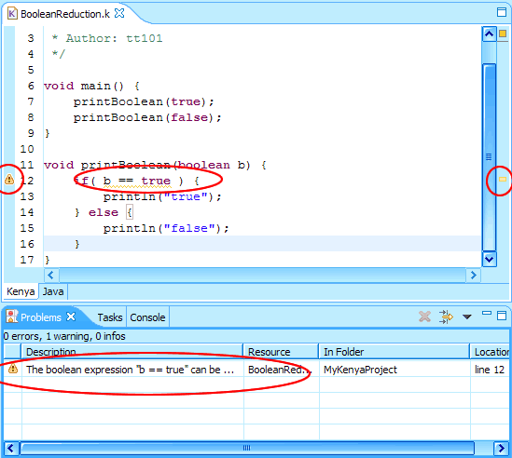
You can see that the style warnings show up in exactly the same way as compile errors do. However, while KenyaEclipse does not offer assistance with compile errors, there is assistance for stilistic mistakes, such as this one. You can trigger the assistant by clicking on the warning annotation or by using the Edit menu item and selecting Quick Fix.
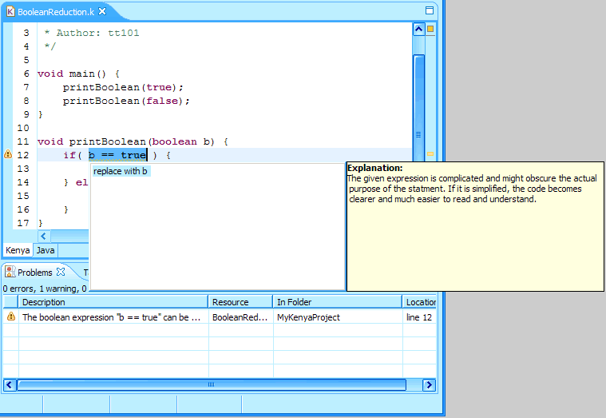
If an automatic solution is available, you will be presented with alternatives for solving the problem at hand and a comprehensive explanation as to why the fix should be applied (shows up after about a second). You can confirm by using enter or double clicking on the (a) solution you wish to apply. To cancel the dialog, use ESC.
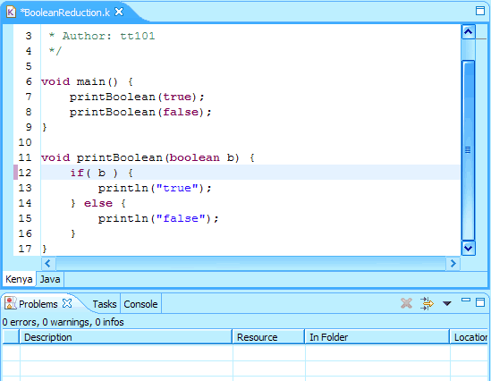
After applying the solution, the document is marked as ‘dirty’, the warning has disappeared and the change ruler contains the change, as if you had done it yourself.

All changes applied by the StyleChecker are un- and re-doable using the normal undo/redo actions.
Configuring the module
The StyleChecker is separately configurable for each file. By right clicking on the file in question (in the Kenya Explorer) and choosing Properties, you can reach the configuration page.
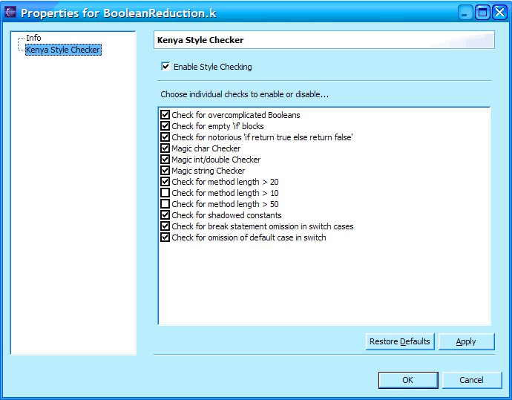
This page allows you to enable or disable style checking altogether or to enable or disable individual checks. If, for example, you disable the ‘Check for overcomplicated Booleans’, you will notice that the warning in our previous bit of code soon disappears (next time the code is compiled).
- Advanced Editor features
This chapter will explain the following advanced features that are part of KenyaEclipse:
- Variable and type occurrence highlighting
- Code assistance (auto completion)
- Parameter hints for method calls
- Source editing, including
  - Comment toggling
  - Block comment toggling
  - Indentation correction
- Refactoring, including
  - Variable renaming
  - Type (class) renaming

Occurrence Highlighting
The occurrence highlighter can be enabled by using its button in the toolbar:
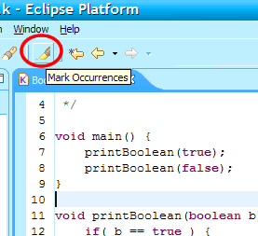

The highlighter is capable of highlighting various things:

Variable references:  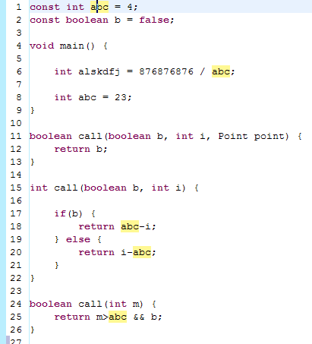 | References to methods:  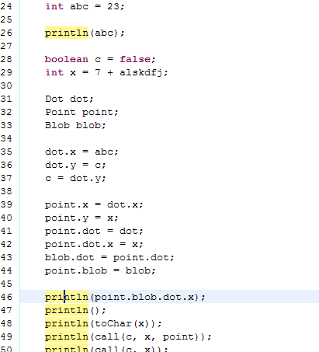
Type (class) references:  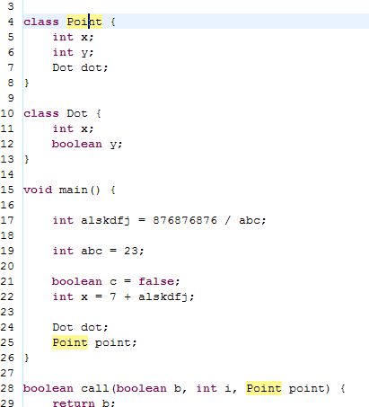 | Method exit points:  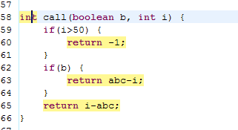

Note that Java 1.5 enumerated types will either not be highlighted or that some occurrences may be missed out.
Code assistance (auto completion)
Code assistance helps you write code faster by letting you complete variable or method names automatically. This function is automatically triggered if you use a qualified name to access fields inside a class, once you type the ‘.’ (dot). You can also bring up the completion dialog yourself by using Content Assist in the Edit menu (Ctrl+Space on most platforms).
The completion dialog gives choices of all variables and methods that you can use at the current position in your code. While you type more characters, it will narrow down the choices to match.
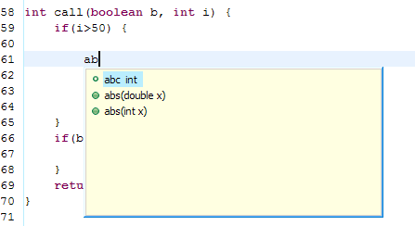
Hitting enter or double clicking the desired completion will insert the completion into the code.

Note that this feature does not support Java 1.5 enumerated types and does not show type parameters for Java 1.5 parameterised methods.
Parameter Hints
Whether it is a predefined method or one that you wrote yourself, you may not be able to remember the exact order in which you need to enter its arguments. Parameter hints solve this problem by showing you the order, names and types of a method’s arguments. This feature can be triggered by selecting Parameter Hints in the Edit menu.
Source editing
To speed up common tasks such as commenting (or uncommenting), the source menu, which is available through the right click menu in the editor contains a few very powerful tools for source editing. The following methods currently exist:

- Toggle comment – adds or removes single line commenting (//) for current selection or cursor position
- Add block comment – requires multiple characters to be selected, encloses them in a block comment (/* */)
- Remove block comment – removes surrounding block comment from current selection or cursor position
- Correct indentation – corrects the indentation of the selection according to bracketing rules
Refactoring
Refactoring is defined to be source tranformation without changing the semantics of the code. There are many useful refactorings for Java. These refactorings are available through the right click menu in the editor. The following refactorings currently exist:

- Rename – Renames all occurrences of the currently selected (or at cursor position) variable, method or class. You will be asked to specify a new name. This can be useful for changing the name of a variable to something more meaningful (rather than a single-character name for instance).

- Known Issues - Troubleshooting
- Debugger sometimes does not seem to suspend after using run or one of the step methods.
Workaround: click onto the stackframe again (maybe even multiple times). Also try selecting other frames and then returning to the top one.
- Debugger leaves highlighted bits after terminating
Try enabling occurence highlighting using the icon in the toolbar, select a variable name and wait for the highlighting to appear, then disable it again.
Alternatively, close the editor and open it again.
- Debugger doesn’t suspend on a breakpoint
If this problem persists, try using the 'stop in main' checkbox in the debug configuration (click on the arrow next to the debug button in the toolbar and select 'Debug')
- Occurrence highlighter does not highlight anything
The occurrence highlighter may not work (or turn itself off) under the following circumstances:
  - errored code
  - you are using Java 1.5 features
  - you have highlighted an overloaded method, where two different declarations have the same number of parameters and return type
- Kenya run configuration has no image
This seems to be die to an Eclipse bug. If you are using a version below 3.0.2, try upgrading to that version (or higher).
- There are random exceptions and an error message box pops up
Please ask your supervisor for help if the problem persists
- Time Plans | Integration of Kenya with Eclipse | 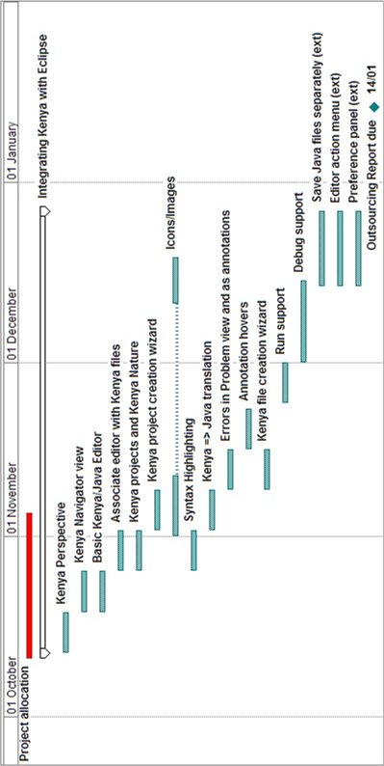  Figure 9.1.1 - Implementation plan for part I  While the ‘Editor action panel’ was dropped entirely, implementing Run and Debug support  stretched out far into January due to various implementation issues (see section 5.1.2).
 | KenyaEclipse Feature extension | 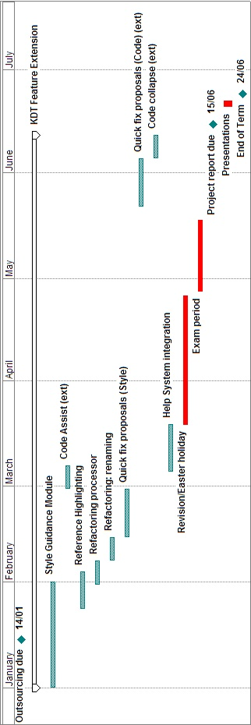  Figure 9.2.2 - Implementation plan for part II  Since the schedule had already been pushed back by issues with the Debugger component, Help System integration was postponed until after the exam period. Because of the difficulties that would be associated with attempting to introduce Quick fix proposals for compilation errors (briefly mentioned in section 6.3.2), this feature was dropped entirely and thus the timing was not an issue.

- Learning To Program in Eclipse

